Borough Council of King’s Lynn and West Norfolk Local Plan 2021-2040 | 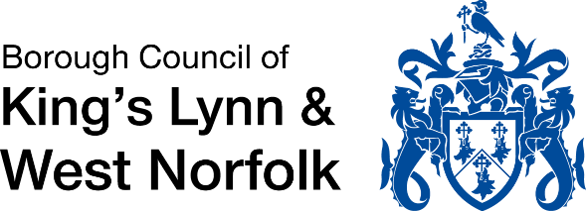
Representation Form
Consultation on Schedule of Main Modifications Part 2 (Gypsy and Traveller site allocations and policy), October 2024
Closing date for submitting representations: 11:59pm, Friday, 29 November 2024

Part A
Section 1: Contact information
 | Respondent details | Agent details (where applicable)
Title:
First Name:
Last Name:
Organisation (where relevant):
Address:
Postcode:
Telephone:
Email:

Part B
Please fill in a separate form for each site and/ or policy
Section 2: Representations
Which Main Modification are you responding on?
Main Modification (MM) ref | Local Plan Paragraph ref | Local Plan Policy ref (if applicable) | Policy title (as applicable)

To which test of soundness does your representation relate?
The Local Plan 2021-2040 is currently under examination by Planning Inspectors, appointed by the Secretary of State). The Inspectors will assess the proposed Main Modifications against the soundness tests. Please indicate whether you consider the proposed Main Modification about which you are responding is:
[Please tick appropriate box] | YES | NO
Legally compliant?

Complies with the Duty to cooperate?

Positively prepared (i.e. seeks to meet the area’s objectively assessed needs)?

Justified (an appropriate strategy, taking into account the reasonable alternatives, and based on proportionate evidence)?
Effective (i.e. deliverable over the plan period)?

Consistent with national policy (National Planning Policy Framework: National Planning Policy Framework (publishing.service.gov.uk))?

Summary of Comments:
Please give details of why you consider the proposed Main Modification that you are commenting on is sound (“Yes”) or unsound (“No”), with reference to the tests above. Please be as precise as possible.
(Continue on a separate sheet if necessary.)
Please note you should cover succinctly all the information, evidence and supporting information necessary to support/justify your comments.
Section 4: Data Protection
The Main Modifications consultations form the final stage(s) of the plan-making process for the Local Plan 2021-2040. Do you wish to be notified further about the Local Plan, at either of the following stages?
Publication of Inspector’s Report (anticipated January 2025)? | Yes |  | No
Adoption of Local Plan (anticipated February 2025)? | Yes |  | No

In complying with the General Data Protection Regulation (UK GDPR) and Data Protection Act 2018, King’s Lynn and West Norfolk Borough Council confirms that it will process personal data gathered from this form only for the purposes relating to the consultation. It is intended to publish responses to this consultation on the Borough Council’s website. However, it should be noted that all personal information (except for names and organisation name, where appropriate) will not be published.
When you give consent for us to process data, you have the right to withdraw that consent at any time. If you wish to withdraw your consent, you must notify us at lpr@west-norfolk.gov.uk or 01553 616200.

Section 5: Signature and Date of Representation
Please sign and date below:
Signature: (electronic signatures are acceptable)
Date:
Please note the following:
- To be considered, your representation will need to be received by 11:59pm on Friday, 29 November 2024.
- The Main Modifications are being consulted upon in two parts. The Part 2 consultation covers site allocations and policies for Gypsies, Travellers and Travelling Showpeople. All other Main Modifications were dealt with through the Part 1 consultation, which ran from 7 August – 2 October 2024 (inclusive).

